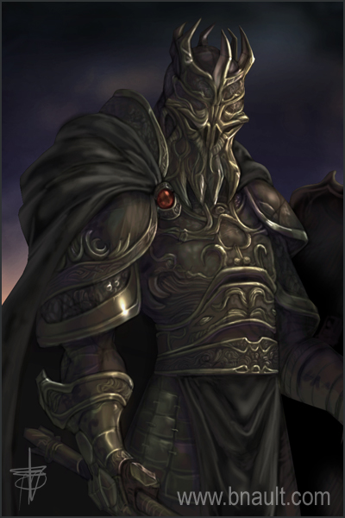
Sir Anthony Bram,
Baron of Tyrconnell; Cursed Knight
6’-4” covered in dull black armor.

ST: 13 [30]
DX: 12 [40]
IQ: 10 [0]
HT: 12 [20]

HP: 10 [-6]
Will: 10 [0]
Per: 10 [0]
FP: 10 [-6]

Damage: Thr: 1d Sw: 2d-1
Basic Lift: 33 lbs.
Basic Speed: 6 [0]
Basic Move: 5 [-5]
Dodge: 9 [0]
Parry (Two-Handed Sword): 10
Size Modifier: 0

Technology Level: 3 [-25]
Cultural Familiarity: Western [0]
Languages: English (Native) [0]
Advantages:
Alternate Form (Ghost Form) (Takes Extra Time (40 Seconds), -20%) [43]
Cursed Knight Form [193]
High Pain Threshold [10]
Night Vision 5 [5]

Disadvantages:
Disturbing Voice [-10]
Wealth (Dead Broke) [-25]

Perks, Quirks and Features:
Always Clean/Spotless [1]
Can’t Float While Substantial [-1]
Chauvinistic [-1]
Dislikes Fops [-1]
Likes Gadgets [-1]
Sexless [-1]

Cursed Knight Form [193] {
Advantages:
Ally (Undead Horse Companion; Frequency (Quite Often, roll of 12 or less) (x2); Minion, +50%; Summonable, +100%; Appears in a Dimly Lit Area Only, -10%) [24]
Cursed Two-Handed Sword (Innate Attack (Impaling 2d+1; Melee Attack (Reach 2), -25%; Can’t Hold Objects, -5%); Innate Attack (Cutting 3d; Melee Attack (Reach 1, 2), -20%; Can’t Hold Objects, -5%)) [29]
Cursed Armor (Damage Resistance 11 (Can’t Wear Armor, -40%)) [33]
Doesn’t Breathe [20]
Doesn’t Eat or Drink [10]
Doesn’t Sleep [20]
Immunity to Metabolic Hazards [30]
Immunity to Psionics [30]
Injury Tolerance (No Blood, Brain, Eyes, Vitals, and Unliving) [40]
Temperature Tolerance 1 (25° - 92°) [1]
Unaging [15]

Disadvantages:
Frightens Animals [-10]
No Peripheral Vision [-15]
Numb [-20]
}

Ghost Form [236] {
Advantages:
Doesn’t Breathe [20]
Doesn’t Eat or Drink [10]
Doesn’t Sleep [20]
Immunity to Metabolic Hazards [30]
Immunity to Psionics [30]
Injury Tolerance (No Blood, Eyes, and Homogeneous) [50]
Insubstantial (Always On, -50%) [40]
Invisibility (Substantial Only,-10%) [36]
Unaging [15]
}

Skills:
Animal Handling (Undead Horse Companion) (IQ+0)-10 [1]
Axe/Mace (DX-1)-11 [1]
Bow (DX+0)-12 [2]
Brawling (DX+0)-12 [1]
Broadsword (DX-1)-11 [1]
Climbing (DX-1)-11 [1]
Hiking (HT+0)-11 [1]
Knife (DX+0)-12 [1]
Lance (DX+0)-12 [2]
Navigation/TL3 (Land) (IQ+0)-10 [2]
Riding (Horse) (DX+2)-14 [8]
Shortsword (DX-1)-11 [1]
Shield (DX+0)-12 [1]
Spear (DX-1)-11 [1]
Stealth (DX+0)-12 [2]
Two-Handed Sword (DX+2)-14 [8]

Techniques:
Hands-Free Riding-14 [4]
Horse Archery-10 [3]

Point Totals:
Attributes and Secondary Attributes: 73
Tech Level, Culture and Language: -25
Advantages: 250
Disadvantages: -35
Perks, Quirks and Features: -4
Skills and Techniques: 41
Total: 300
Undead Horse Companion
A large skeletal horse-like creature fully covered in dull black barding (armor.)

ST: 24 (Size Modifier +1, -10%; No Fine Manipulators, -40%) [120]
DX: 9 [-20]
IQ: 3 [-140]
HT: 12 [20]

HP: 24 [0]
Will: 11 [40]
Per: 12 [45]
FP: 12 [0]

Damage: Thr: 2d+1 Sw: 4d+2
Basic Lift: 115 lbs.
Basic Speed: 5.25 [0]
Basic Move: 7 [10]
Dodge: 9 [0]
Size Modifier: +1

Technology Level: 3 [-25]
Cultural Familiarity: Western [0]
Languages: English (Broken/None) [-5]

Advantages:
Combat Reflexes [15]
Cursed Barding (Damage Resistance 5 (Can’t Wear Armor, -40%)) [15]
Dark Vision [25]
Enhanced Move 1 [20]
Extra Legs (Four Legs) [5]
Doesn’t Breathe [20]
Doesn’t Eat or Drink [10]
Doesn’t Sleep [20]
Hooves [3]
Immunity to Metabolic Hazards [30]
Immunity to Psionics [30]
Injury Tolerance (No Blood, Brain, Eyes, and Vitals, Unliving) [40]
Peripheral Vision [15]
High Pain Threshold [10]
Regeneration (Slow) [10]
Regrowth [40]
Sharp Teeth (Cutting 2d) [1]
Temperature Tolerance 10 (-55° - 120°) [10]
Unaging [15]
Unfazeable [15]

Disadvantages:
Appearance (Monstrous) [-20]
Cannot Speak [-10]
Colorblindness [-10]
Frightens Animals [-10]
Hidebound [-5]
Horizontal [-10]
Intolerance (Everyone But Master) [-10]
No Fine Manipulators [-30]
No Sense of Smell/Taste [-5]
Sense of Duty (Master) [-5]
Wealth (Dead Broke) [-25]

Perks, Quirks, and Features:
Horse Comes with Riding Equipment (Bit, Bridle, Saddle, Stirrups, Etc.) [1]
Sexless [-1]

Skills:
Brawling (DX+1)-12 [8]
Mount (DX+5)-14 [20]

Point Totals:
Attributes and Secondary Attributes: 75
Tech Level, Culture and Language: -30
Advantages: 349
Disadvantages: -140
Perks, Quirks and Features: 0
Skills and Techniques: 28
Total: 282

